Outcome
- This procedure details the process for configuring a cosmos db backup and restore scenarios .

Prerequisites
The following are prerequisites for the successful completion of this procedure:
- Approved change within BMC Helix with appropriate notes attached to the change.
- Check for Permissions to Subscription.
- Determine infrastructure components within the scope of the health check
- Confirm User Performing Activity has CosmosRestoreOperator and CosmosDBOperator role Assigned.
Actions
- Confirm the Backup Policy has been configured for the Database. Configure the Backup Policy and select options based on Business Requirement.
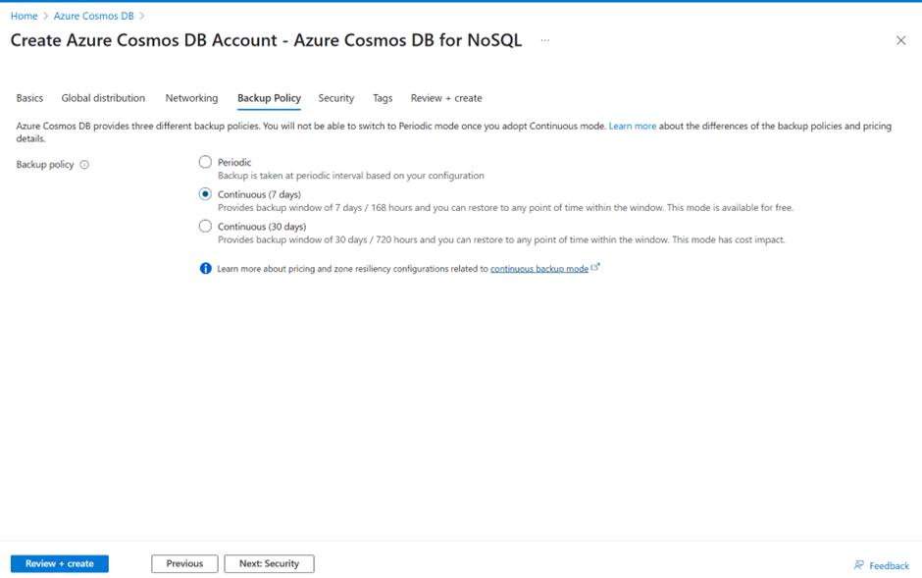
- Once The Backup is Configured. Backup will be initiated Automatically.
- Restore Scenarios: -
3.1 Restore to Same Account: Note When restoring to same account only database or container that is deleted can be recovered. Full Database or Container Level Restoration.
Click On Settings on Database Property Menu and then Click Point in Time Restore Option
Select Restore to Same Account Option Tab and select the backup restore point which needs to be restored to. Please note restore to same account can be done at container or Database Level Only.
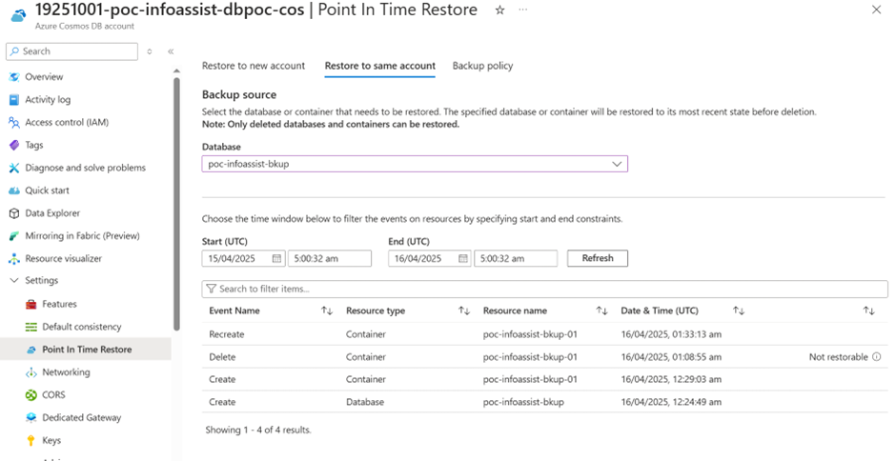

3,2 Point in time recovery to a different Account.
Select Restore to New Account Tab. Specify the Time Period to which the restore is required and a new Account Name.
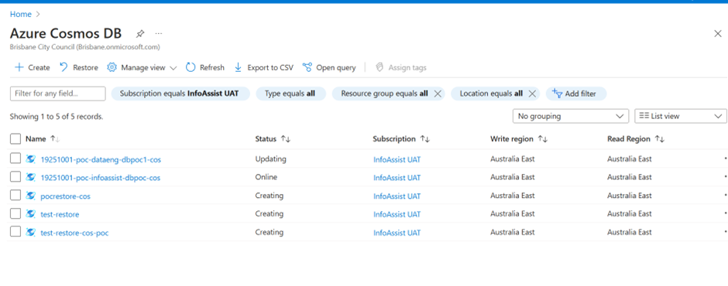
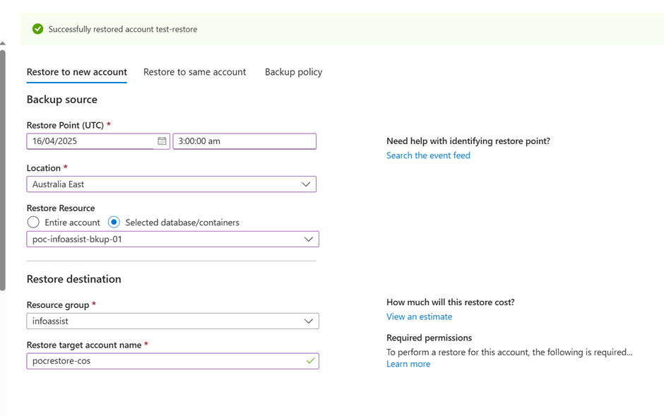
Insert a New Record Database with Value “ars420”
Run A select query to retrieve the newly inserted Record.
After data insert ars420

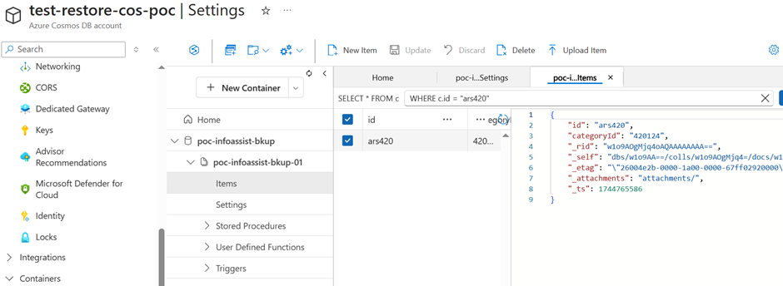

Now Restore Database to a Point Before “ars420” was inserted in Database.
Before Data Insert ars420

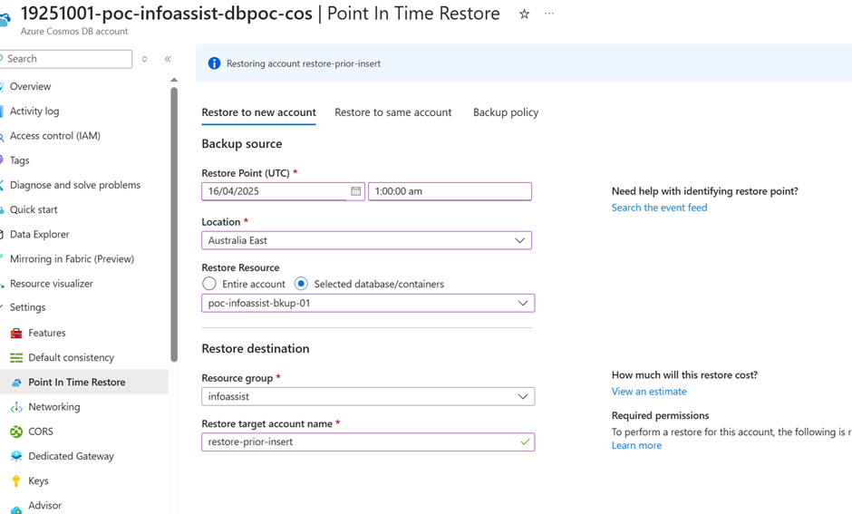

After Successful Restore Operation. Try retrieving the record. The query returns no output confirming database has been restored to a state prior to Insert “ars420”

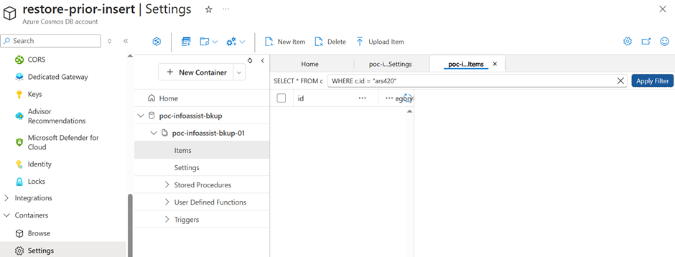
3.3 Restoring Whole Account

Steps to Restore whole Account which has been deleted
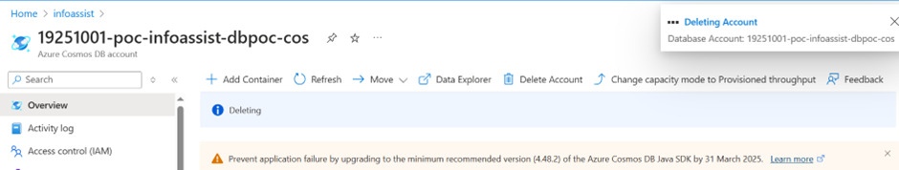

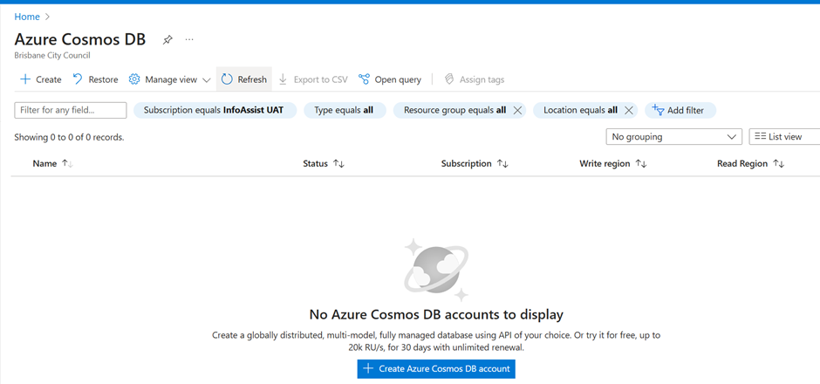
Click On Restore Tab
